**Ideation Phase**

**Define the Problem Statements**

|  |  |
| --- | --- |
| Date | 28 NOVEMBER 2025 |
| Team ID |  |
| Project Name | BOOK A DOCTOR |
| Maximum Marks | 2 Marks |

**Patient Problem Statement Template:**

To define the core problems patient face while searching for doctor, and use those insights to guide the book a doctor consult.

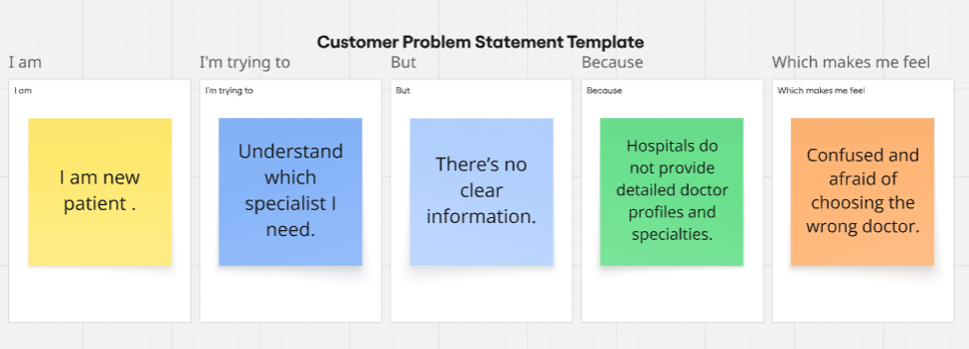

Reference: <https://miro.com/templates/customer-problem-statement/>

|  |  |  |  |  |  |
| --- | --- | --- | --- | --- | --- |
| **Problem Statement (PS)** | **I am (Customer)** | **I’m trying to** | **But** | **Because** | **Which makes me feel** |
| PS-1 | Patient. | Book a doctor appointment quickly. | I can’t find available doctors in my time slot. | Hospital websites don't show real-time doctor availability. | irritated and anxious. |
| PS-2 | Working professional | Schedule a consultation without taking leave. | appointment timings clash with my work hours. | Most doctors only provide appointments during office hours. | Helpless and stressed. |